Performance Testing
Model Performance Test
Date | 14 APRIL 2025
Team ID | SWTID1742640402
Project Name | MyRide
Maximum Marks | 4 Marks

1. Key Performance Metrics
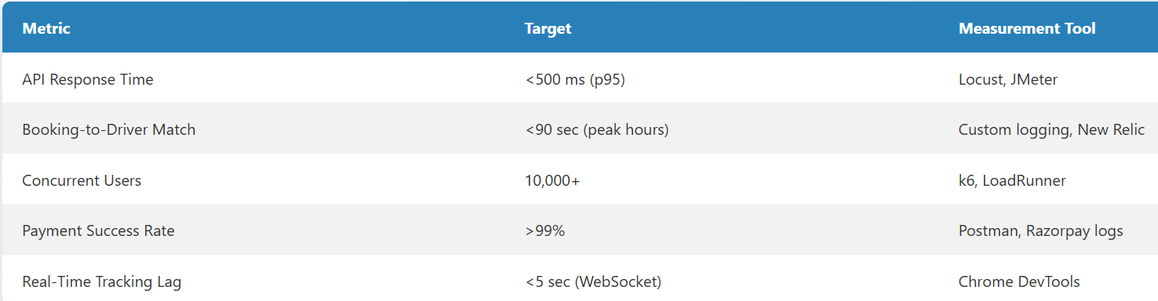

2. Test Scenarios
a. Load Testing
- Simulate 10,000 users booking rides simultaneously.
- Measure:
  - API latency (POST /api/bookings).
  - Database query performance (MongoDB Atlas metrics).
b. Stress Testing
- Spike to 20,000 users during "peak hour" simulation.
- Monitor:
  - Node.js server CPU/RAM usage (AWS CloudWatch).
  - Auto-scaling triggers (if using Kubernetes).
c. Endurance Testing
- Sustain 5,000 active users for 24 hours.
- Check for:
  - Memory leaks (Node.js heap dumps).
  - Database connection pool exhaustion.
d. Real-Time Tracking Test
- 100 drivers emitting location updates every 10s via Socket.io.
- Validate:
  - Passenger app reflects updates with <5s lag.
  - WebSocket server handles bursts (e.g., traffic jams).
e. Payment Gateway Reliability
- Process 1,000 transactions/minute with Razorpay/Stripe.
- Track:
  - Failed transactions (retry logic efficacy).
  - HTTPS handshake time.

3. Tools and Setup
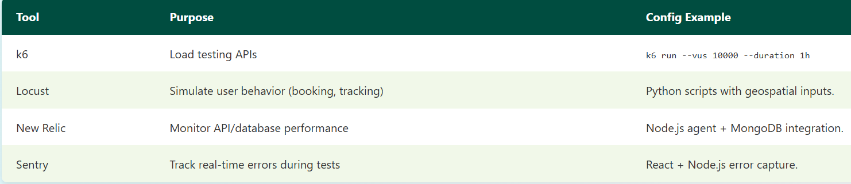

4. Test Data Preparation
- Geospatial Data:
  - Seed MongoDB with 10,000 drivers (lat/lng spread across a city).
- User Profiles:
  - Generate 50,000 test passengers (diverse locations, payment methods).
5. Pass/Fail Criteria
- Pass: all test cases passed
6. Optimization Strategies
- Database: Add compound indexes (location_2dsphere, booking_status).
- Caching: Redis for frequent queries (e.g., "nearby drivers").
- CDN: Offload static assets (maps, UI files).

